What is Emla Cream
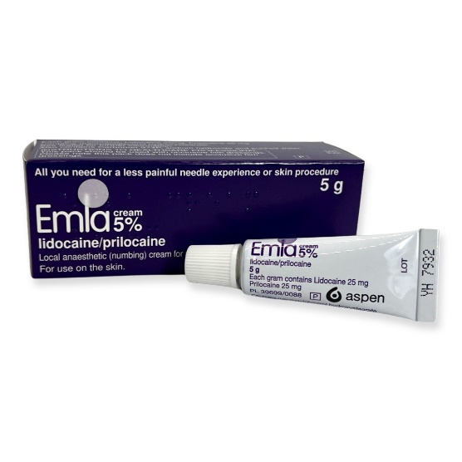 | Emla cream is a numbing cream.  Numb mean that you can’t feel anything when the cream is put on your arm.
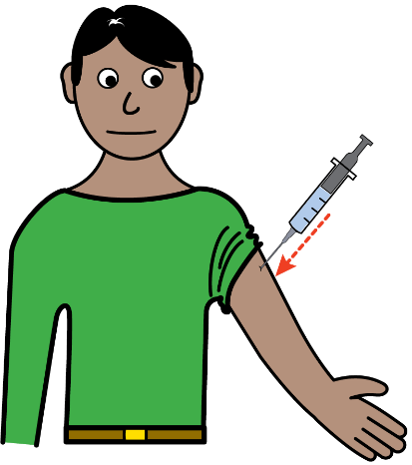 | It is used on the skin before having an injection.
 | This will make the area of your skin numb before you have your injection.
 | This will stop you feeling any pain.
 | It can be bought from a pharmacy or given to you by your doctor.
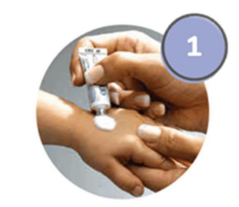  HOUR  BEFORE | This must be applied to the skin around the area for the injection an hour before you have your injection.
  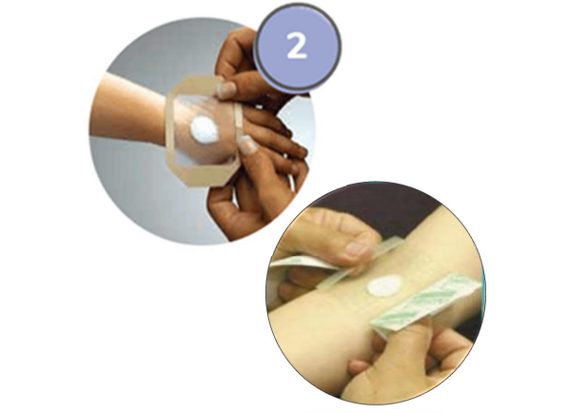 | Putting the cream on will not hurt.  When the cream has been put on a clear dressing should be put on top to keep the cream in place.
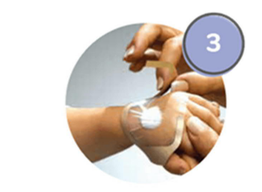 | The doctor or nurse will remove the clear dressing before they give you your injection.
 | Then the nurse will give you your injection.  You won’t feel the injection because you have emla cream on.

