Having a vaccination
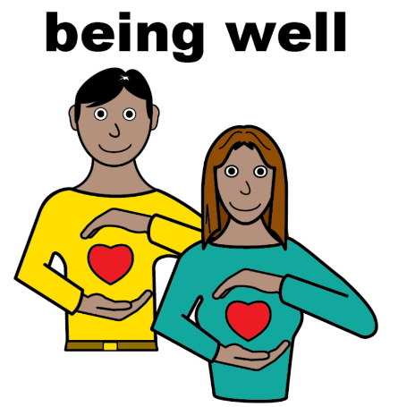 | Vaccinations can help you stay well and can protect you from feeling unwell.
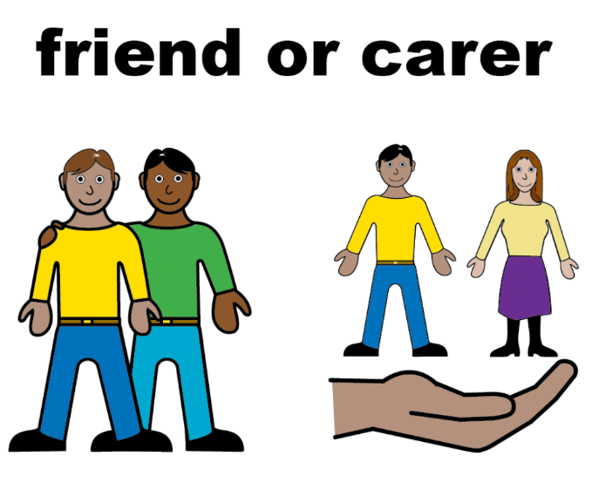 | When you go to the doctors the doctor or nurse will explain that they are going to give you a vaccination.  You can take a parent, carer or friend with you for support.
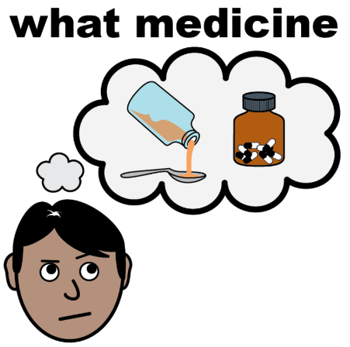   | They will tell you what your vaccination is for.  They will explain what they are going to do.
 | You should tell the doctor or nurse if you are worried.
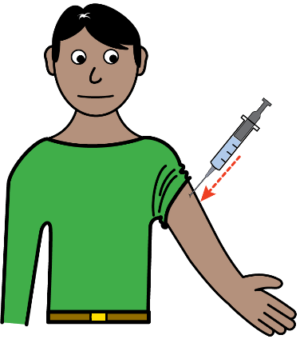 | The doctor or nurse will tell you where they are going to give you the injection.
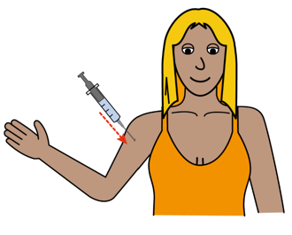   | This might be in your arm tummy or bottom.  The doctor or nurse will clean the area of your body where they are giving you the injection.
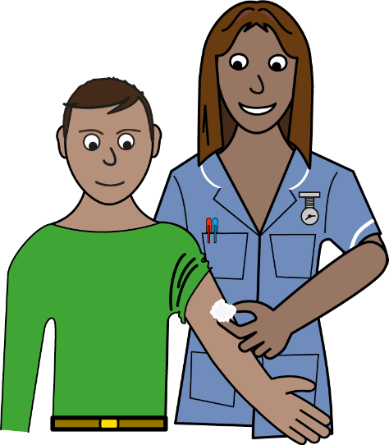 | The injection might be a little bit sore but only for a couple of seconds.  The doctor or nurse might put some cotton wool where they gave you the injection.

