Brushing your teeth
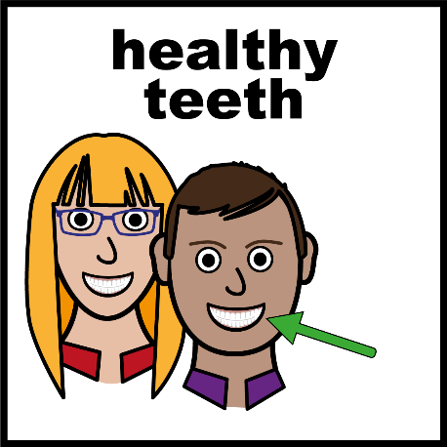 | It is important that your mouth is healthy.
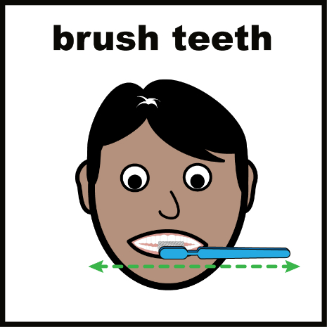 | To keep your mouth healthy, it is important to brush all your teeth.
  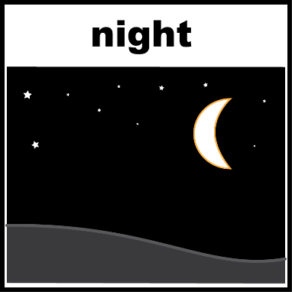 | You should brush your teeth twice a day.  When you wake up and before you go to bed.
2 minutes | You should brush your teeth for two minutes every time.
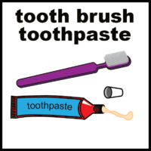 | Wet your toothbrush and use a small amount of toothpaste.
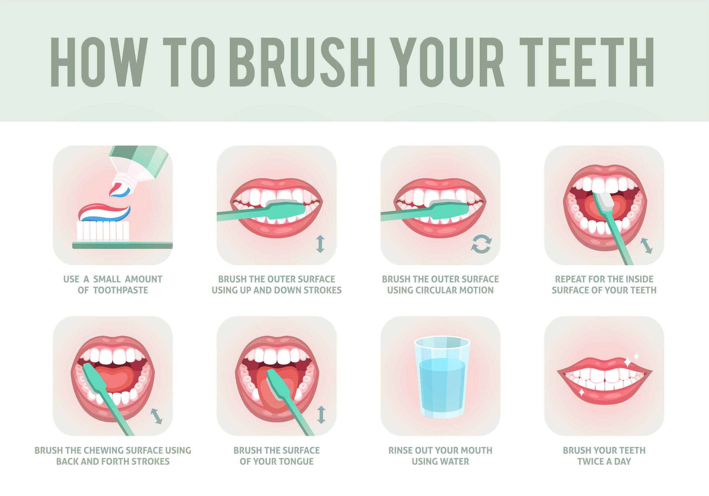 | First brush the front of all your teeth.  Make sure you brush every tooth.
 | Next brush the inside of all your teeth.
 | Next brush the top of your bottom set of teeth.
 | Make sure you brush all parts your teeth.
 | Finally brush your tongue.
 | Make sure to spit out your toothpaste.
 | You now have clean teeth

