Breast Awareness
‘Check your boobs!’
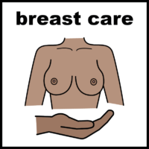 | Why do I need to check my breasts?  Whatever our age, size or shape it’s important we take care of our breasts.  Being breast aware is part of caring for our bodies. It means getting to know how our breasts look and feel so we know what is normal for us.  We can then feel more confident about noticing any unusual changes like a lump.
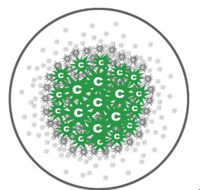  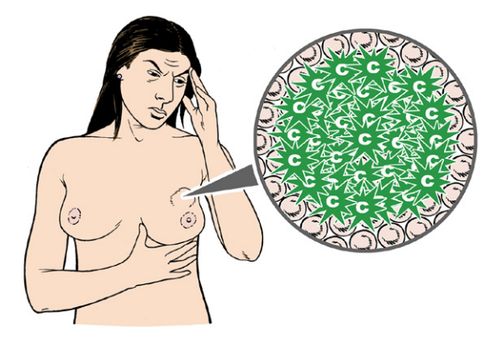 | What is cancer?  Cancer is a change of cells in your body  When the cells grow, they become a  lump in your body  This lump is called a tumour
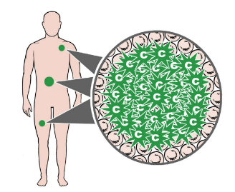  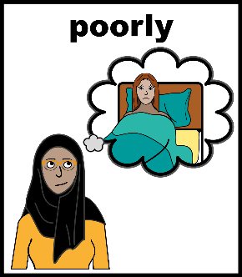 | More about cancer  Cancer is a serious health condition.  If cancer is left untreated it can spread to other parts of your body.  Cancer can make you very poorly.
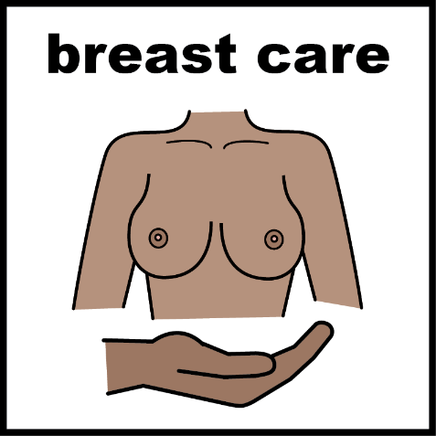 | Breast Screening  Breast screening is a test to see if your breasts are healthy.  Breast screening is for women aged 50 and over.  Breast screening is very important.
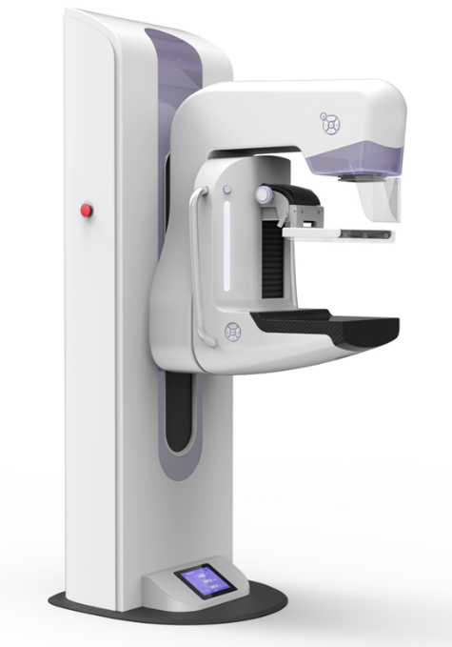 | Mammograms  The breast screening test is called a mammogram.  A mammogram takes a photo inside of your breasts. A bit like an having an x-ray but on your breasts.  The test is done with a machine like this one.
The person doing the test is called a mammographer. This will always be a woman.

She will place your breasts on to the machine one at a time.

The machine will flatten your breast and hold it in place.

You will feel your breast being squeezed.

The x-ray machine may hurt a little bit but this will only be for a few seconds.

You need to keep very still for a few seconds while the images are taken.
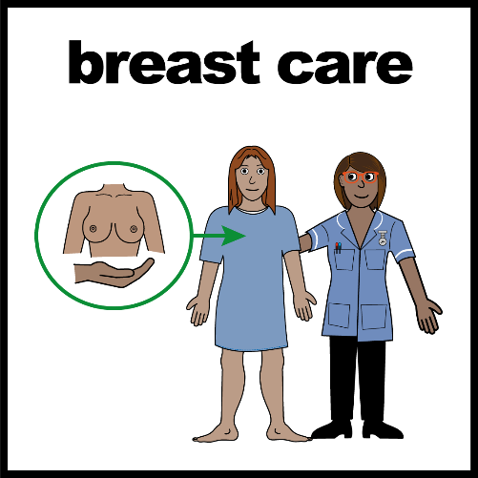 | Why is breast screening important?  Breast screening can find small changes in your breasts that might be too small to see or feel.  These small changes can grow and become cancer.  Breast screening is a way of finding breast cancer.
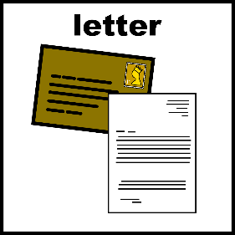  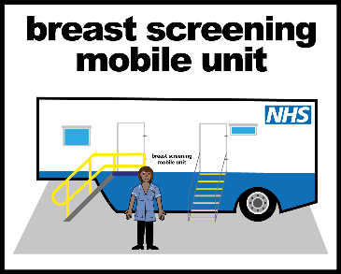  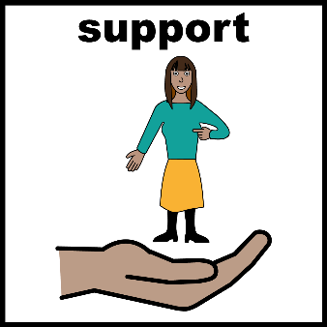 | Your mammogram appointment  You will get a letter to invite you for your breast screening test.  Your appointment will be at a breast screening clinic.  You can speak to your carer or someone that supports you if you are feeling worried.
  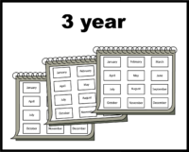 | More about your mammogram appointment  All women get invited for a mammogram at the age of 50  It does not mean you have cancer  You will be invited for a mammogram every 3 years once you are 50 years old
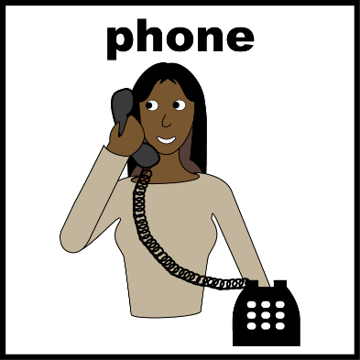  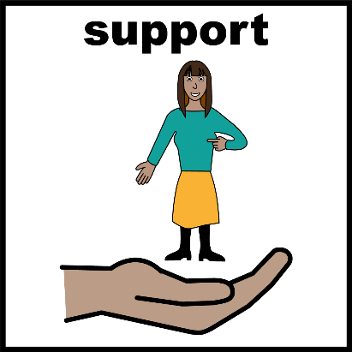 | Getting the letter for your appointment  You can ring the clinic to tell them you have a learning disability.  You can tell them things that will make the appointment easier for you for example:  - A longer appointment  - To bring someone to support you  - Easy read information  - A visit to look at the machine
  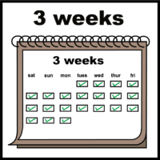 | After your appointment  About 3 weeks after your appointment you will get your results though the post.  Most of the time your results will be fine.  Sometimes they might ask you to go back for another mammogram.
 | It is nothing to worry about.  If you are worried, then it is important that you tell someone.  This will mean that you get the support you need to have your mammogram.
