Bowel Cancer Screening
Bowel cancer is a serious disease that can make you very poorly.

Bowel cancer screening is a way to look for small amounts of blood in your poo.

It’s a test to see if you have bowel cancer.

It is a very important test that helps find bowel cancer at an early stage.

This booklet tells you how to use the bowel cancer screening kit.
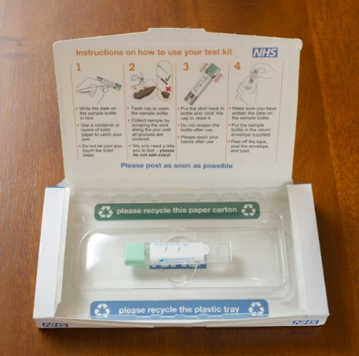 | Around the age of 54 you will get a bowel cancer screening kit through the post.  Some people might get it at a younger or older age.  It will look like this. You will also get an envelope and a letter explaining what it is.
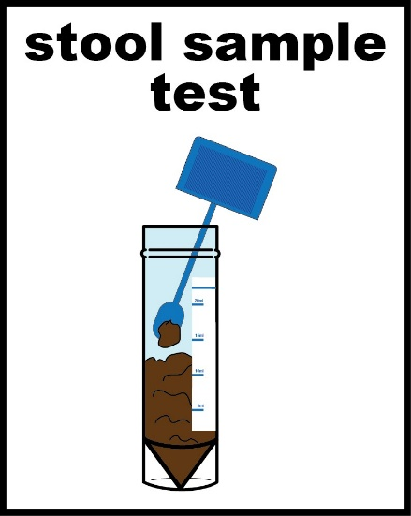 | To do the test you need to collect a small amount of your poo so it can be tested.  You collect your poo in a sample bottle that looks like this picture.
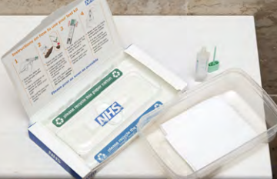 | You can collect your poo using some toilet paper and a clean empty container.
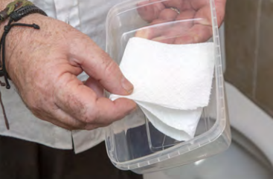 | Take the clean empty container and the bowel testing kit into the bathroom with you.  Put some toilet paper in the bottom of the container.
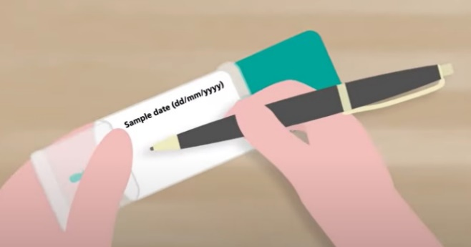 | Write the date that you’re taking the test on the sample bottle.
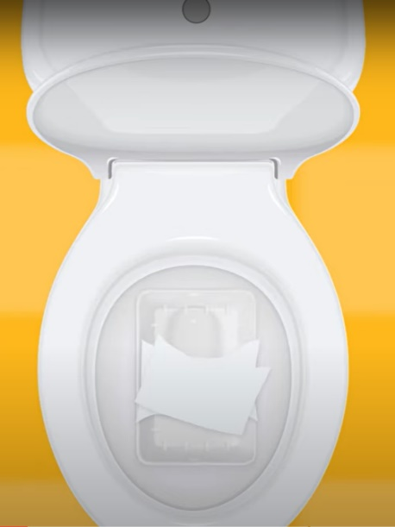 | Before you have a poo, put the container in the toilet so you can catch your poo before it goes into the water.
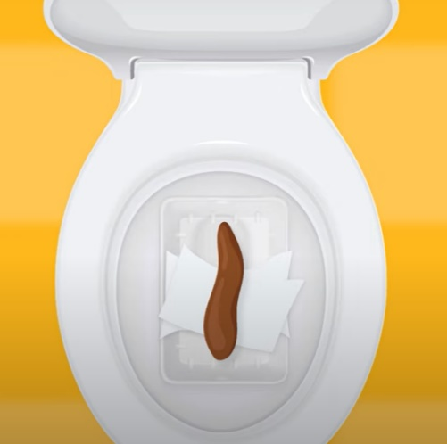 | It is important that you do not let the poo touch any of the toilet water or your wee.
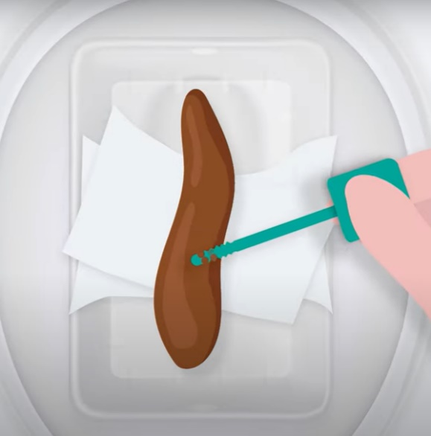 | When you have been for a poo open the sample bottle and swipe the stick on the poo that’s in the container.  Swipe the stick until all the gaps are filled with poo.  This will collect a sample of your poo.
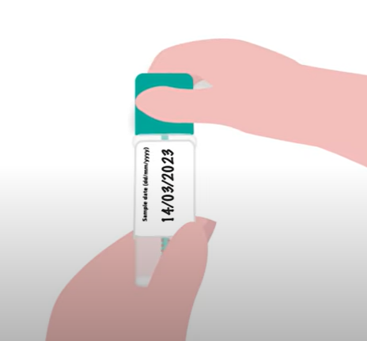 | Put the stick back inside the sample bottle and make sure the lid is closed tight.
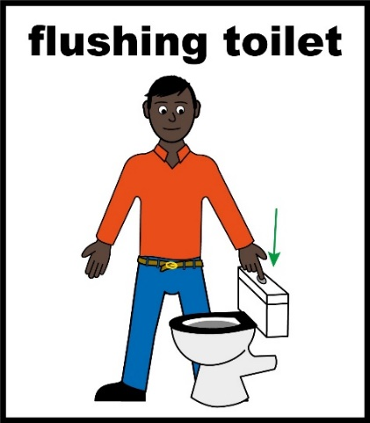 | You can now tip the poo that’s in the container into the toilet and flush it away.
 | Now wash your hands with soap.
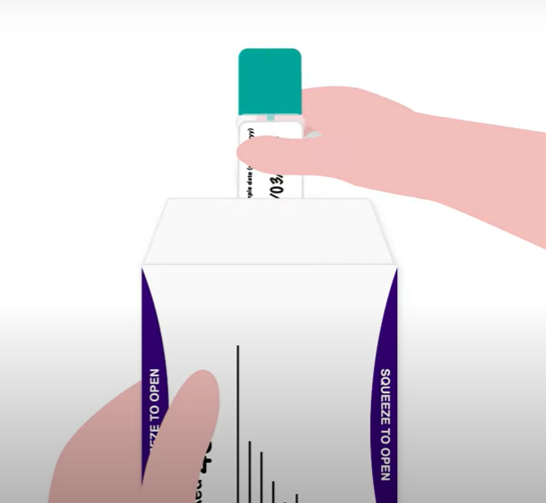 | Put the sample bottle in the envelope that came with the test kit.
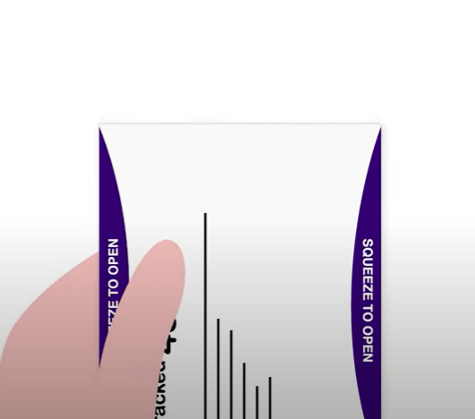  close the envelope. | Peel off the sticky tape and close the envelope.
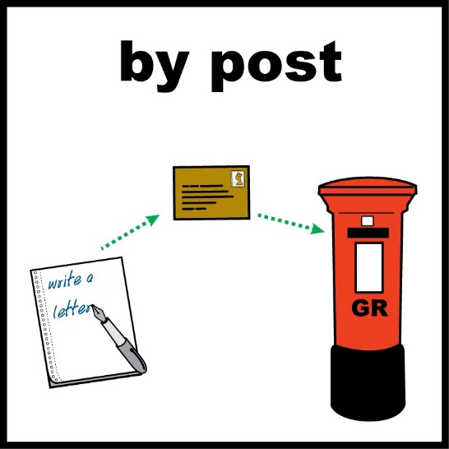 | Put the envelope in a post box as soon as possible.
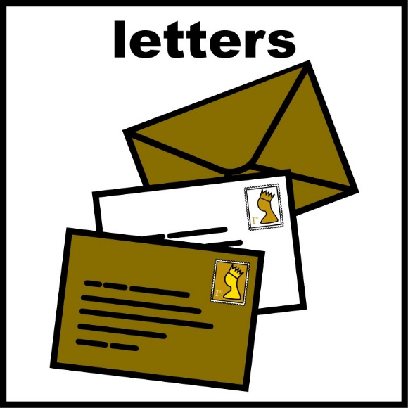 | You should get your results by letter in 14 days.

