Blood pressure and sepsis
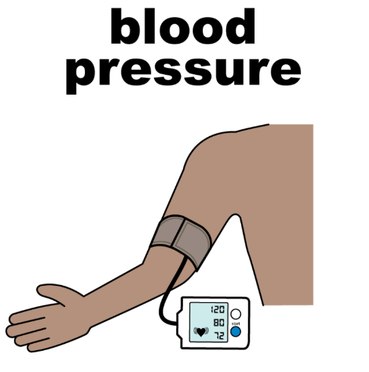 | Blood is pumped around your body by your heart.  Blood pressure measures how fast blood is being pumped around your body.
120  80 | A normal blood pressure is 120/80
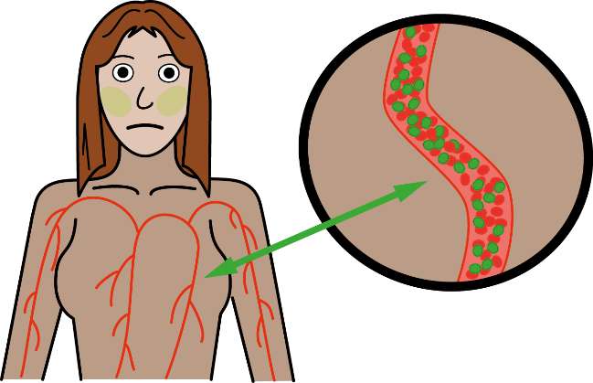 | Sepsis is when your body reacts badly to an infection.
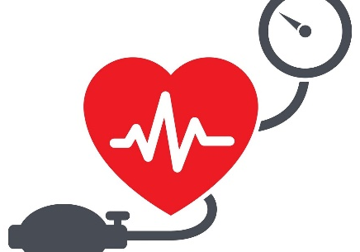 | If someone has sepsis their blood pressure will change
 | If the doctors or nurses think you have sepsis, they will need to check your blood pressure.
 | Usually, your blood pressure will go lower than normal if you have sepsis.

