
AAA Screening
(Abdominal Aortic Aneurysm)
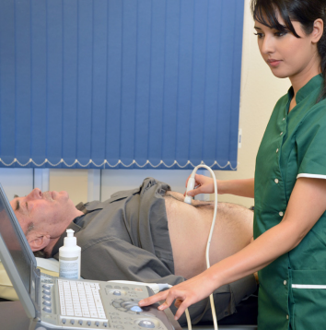 | The full name for this screening is Abdominal Aortic Aneurysm screening.  Because it has a long name, most people call it ‘triple A’ screening.
 | AAA screening is for people who were born as a man.  You will get invited for AAA screening around your 65th birthday.  The invite might come before or after your 65th birthday.
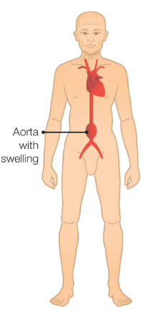 | In your body you have something called an aorta which pumps blood from your heart to the rest of your body.  An aorta is a type of vessel.  Sometimes, your aorta can become too big which can cause an abdominal aortic aneurysm or AAA.  An aneurysm happens when a vessel swells up.
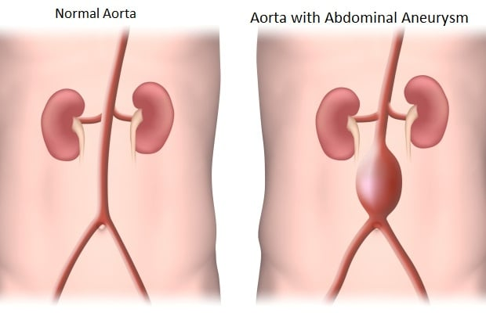 | Most people will have no aneurysm because their aorta is strong and healthy.  Some people might have a small or medium sized aneurysm.  If your aorta becomes too big and weak it can burst, and you might die.    AAA screening can see if you have an abdominal aortic aneurysm.  AAA screening can save your life.  It’s your choice if you want to have the screening or not.
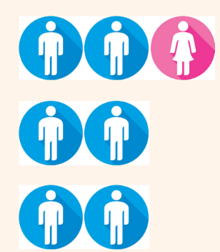 | Everybody has an aorta in their tummy.  Men over the age of 65 have more chance of getting an abdominal aortic aneurysm than women.  That’s why only men are offered screening.
 | If you have high blood pressure or if you smoke, you are at more risk of having an abdominal aortic aneurysm.
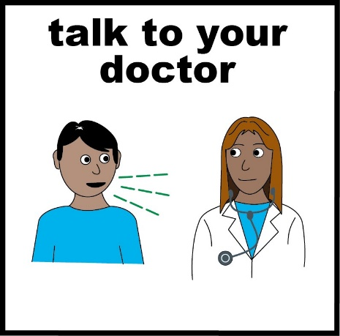 | If you are unsure about having abdominal aortic aneurysm screening, then you can talk to your doctor about it.
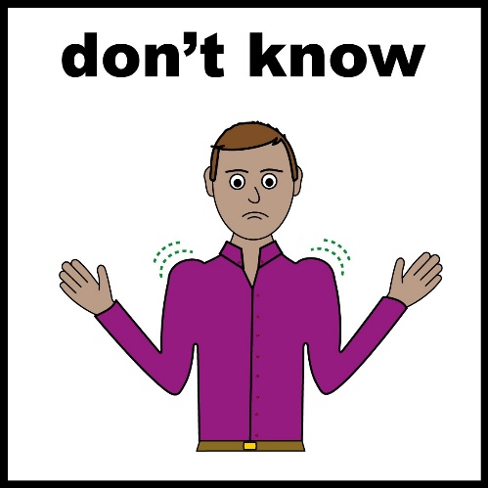 | If you have an aneurysm, you might not know unless you get screening.  Many people don’t know they have one.
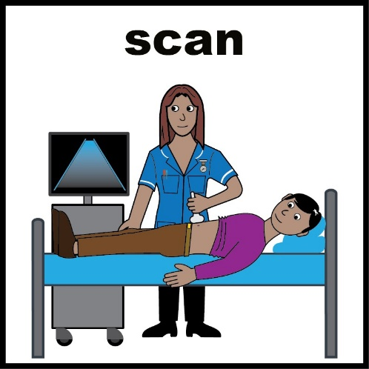 | To see if you have an abdominal aortic aneurysm all you need to have done is an ultrasound.  An ultrasound is the same scan that is used on pregnant people’s tummies to see if their baby is healthy.
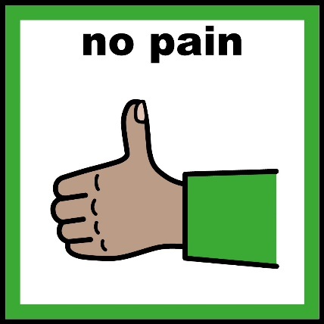 | An ultrasound scan does not hurt.
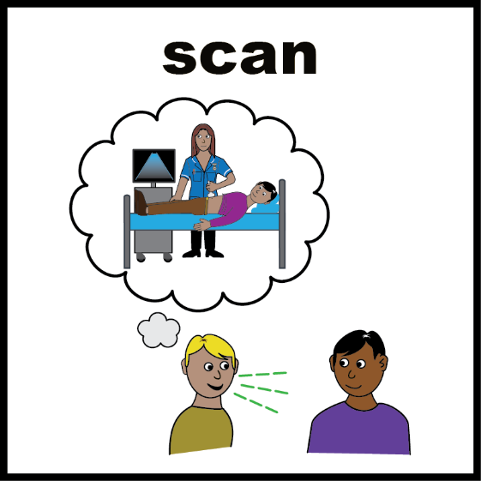 | When you go for your ultrasound the health professional will explain what they are going to do.  They will ask you to lie down on the bed.  They will also ask you to lift or unbutton your top.  You do not need to get undressed.
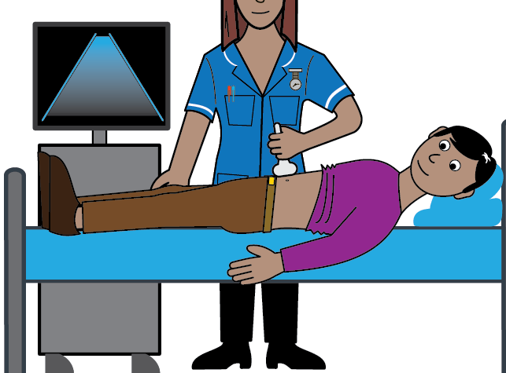 | The health professional will ask you if they can put clear gel on your tummy.  The gel might be a bit cold.  They will then ask you if they can put the scanner on your skin like this.
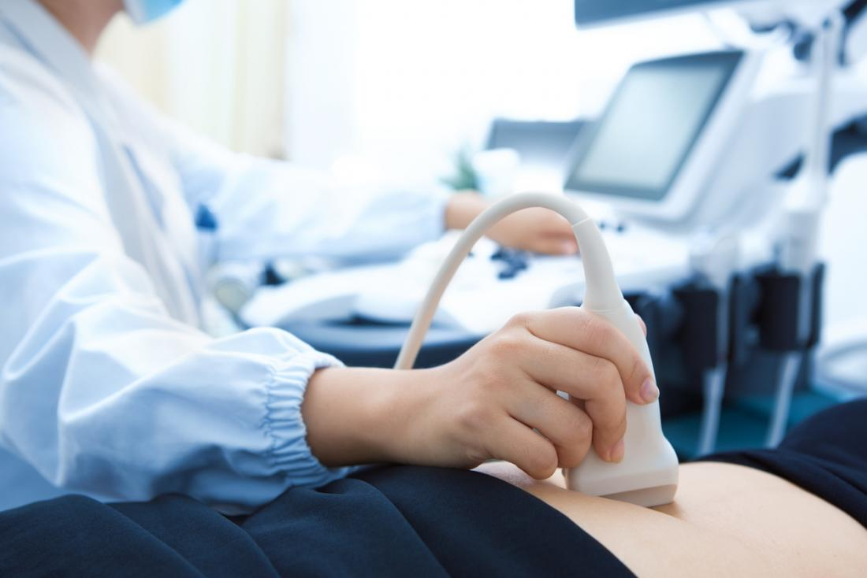 | They will move the scanner around on your tummy.  The scan will show them a picture of your aorta so they can see how big it is.
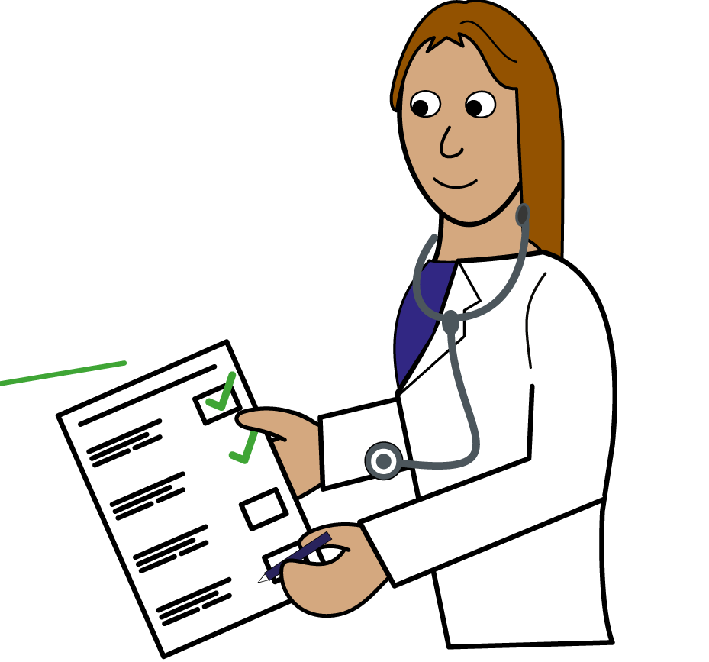 | Once they have seen your aorta on the screen they can tell you your results straight away.  This means they will tell you if you have:  - No aneurysm  - A small aneurysm  - A medium aneurysm  - A large aneurysm
 | If you have no aneurysm this is a good result.  Most men will have no aneurysm.  You will not need anymore more checks or any treatment.
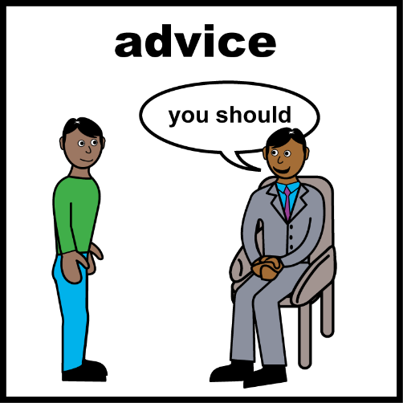 | If you have a small aneurysm, it means your aorta is a little bit wider than it should be.  They will ask you to come back in 1 year to have it checked again.  The doctor might give you some medicine to take so your aneurysm does not get any bigger.  They will also give you advice about how you can stop it getting any bigger.  They might also take your blood pressure.
If you have a medium aneurysm, it means your aorta is wider than most other peoples.

It is important you get it checked every 3 months to make sure it isn’t getting any bigger.

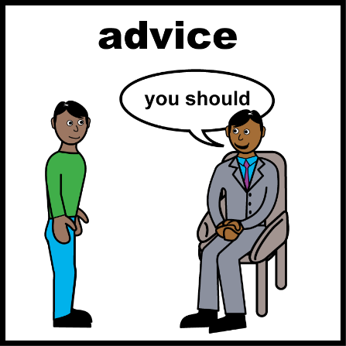  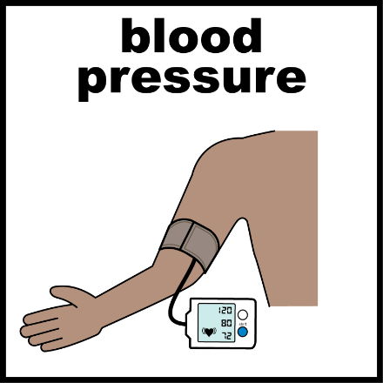 | The doctor might give you some medicine to take so your aneurysm does not get any bigger.  They will also give you advice about how you can stop it getting any bigger.  They might also take your blood pressure.
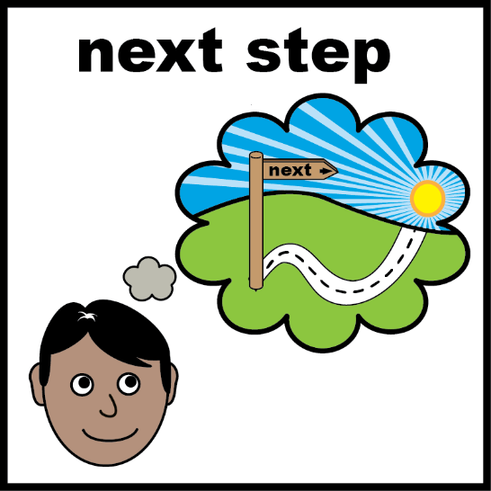 | If you have a large aneurysm this means your aorta is much wider than other peoples.  Not many men have a large aneurysm.  If you have a large aneurysm the doctor will talk to you about what happens next.
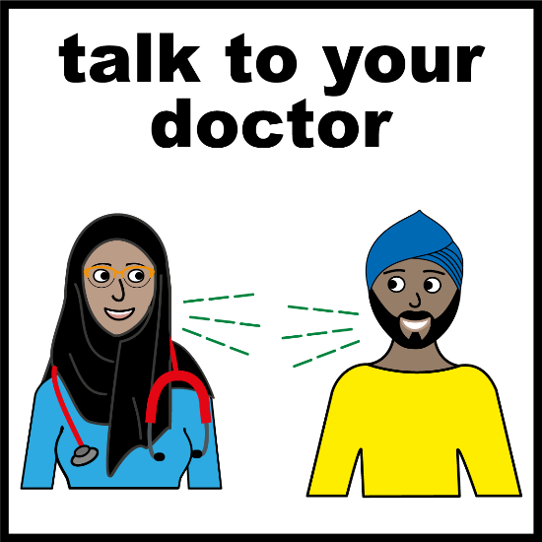 | If you have a large Aneurysm, then the treatment will usually be an operation.  The doctors at the hospital will talk to you about the operation.  They will talk to you about the good and bad things about having the operation.

