NEW PATIENT APPLICATION FORM

PLEASE ANSWER ALL QUESTIONS CAREFULLY IN BLOCK CAPITALS.
Incomplete applications will not be processed.

Recent changes to legislation state that overseas visitors, when accessing healthcare, are legally obliged to declare that they are from overseas. When a patient answers ‘no’ the practice will share the patient registration form with the overseas visitors team at East Lancashire Hospitals NHS Trust.

Are you permanently resident in the UK? |  |  |  | Yes |  |  | No
Are you legally entitled to live in the UK? |  |  |  | Yes |  |  | No
Do you hold either a non-UK issued EHIC/SI form?  (If yes provide a leaflet explaining the rules and entitlements for overseas patients accessing NHS services in England) |  |  |  | Yes |  |  | No
DATE OF APPLICATION |  |  |  | DATE OF BIRTH
FIRST NAMES |  |  |  | PLACE OF BIRTH
SURNAME |  |  |  | CURRENT GP
NHS NUMBER - Available from your current GP surgery
ADDRESS/POSTCODE
HAVE YOU BEEN REGISTERED HERE BEFORE? | Yes | No | No |  | Home Tel:  Mobile:
 |  |  |  |  | EMAIL:
Language(s) Spoken:
If English is not your first language – would you need additional support from Language Line for your appointments? Or are you able to bring someone with you to interpret?
Accessible Information - Please tell us of any particular communication needs we should consider prior to contacting you. (e.g. impaired vision/hearing loss).
Please give the reason for leaving your last Practice
Please give the reason for choosing our Practice
When returning these forms you must bring the following with you –

- PHOTO ID ( Passport (& visa)/ Driving licence)
- PROOF OF ADDRESS ( Recent utility bill etc. – not driving licence)
- FOR CHILDREN UNDER 5 YEARS OLD – THEIR ‘RED BOOK’ OR OTHER IMMUNISATION RECORD.
- DETAILS OF ANY ON-GOING MEDICAL CONDITIONS AND LIST OF CURRENT MEDICATION (From your current GP)
If you are accepted as a patient and given an appointment please bring:
- A sample of urine with you.
- A print off showing your repeat items from your previous GP.
- If you have children up to the age of 5 please bring their red book to your appointment.

Out of Area Registration
- New arrangements introduced from January 2015 give people greater choice when choosing a GP practice and GP practices now have the option to decide whether to accept, as registered patients, new patients or retain existing patients who live outside the GP area. When a new patient or existing patient is identified as living outside of the Practice area the Practice will review each case before deciding whether it is practically/clinically appropriate to accept or re-register an existing patient as an ‘Out of Area’ patient but without the obligation to provide home visits or whether to ask the patient to register with a GP closer to home.

If accepted as an ‘Out of Area’ Patient
- You will be able to attend the practice and receive the full range of available services.
- If you have an urgent care need and are unable to visit the surgery please contact the practice. If we determine you need access to services closer to your home we may ask you to call NHS 111 who will direct you to a service that has been established by NHS England specifically for ‘Out of Area’ patients. In these circumstances you will need to provide our practice details (above) to the care provider to allow them to transfer your consultation data to us so we can update your records.
- We may review your registration in the future to see if your health needs have changed and whether it would be more appropriate for you to be registered with a practice closer to your home.
- For further information visit the NHS Choices website www.nhs.uk

APPOINTMENTS POLICY
- When booking an appointment please provide staff with as much information as possible. The GPs ask that you be prepared to answer a few questions about your symptoms/reason for requesting an appointment so the receptionists can navigate you to the appropriate service or clinician.
- All consultations (with a doctor or a nurse) are by appointment only. GP and Nurse Appointments are available to book on the day and in advance. Requests for urgent appointments will be assessed by a clinician who will decide on an appropriate course of action.
- Home visits for housebound patients and must be requested before 10:30 am.
- We are a group practice and you can request to see any of the GPs. Not every GP will be in surgery every day and your GP of choice may not always be available. All patients are allocated a named GP. This does not mean you will always see this GP but he/she will be ultimately responsible for overseeing your care.

MISSED APPOINTMENTS
- Each failure to attend will be recorded in your patient records and a letter will be sent reminding you of the Practice Policy. The practice will immediately remove patients from the register at the third failed appointment. If you cannot attend an appointment you must cancel at least 2 hours before your appointment time. If an appointment is cancelled too late for us to re-book, it will be recorded as a failure to attend.

PRESCRIPTION POLICY
- Prescriptions can be ordered by calling the prescription line 02182 644335 between 12pm and 3pm, registering for online access or submitting a written request at reception.
- It always takes us two working days (we do not work weekends or bank holidays) from receipt of your request for your prescription to be ready to collect.
- Prescriptions will not be issued before they are due. If you are going on holiday and need to order early you must state this on your written request telling us when you are going away and how long for.
- Prescriptions are issued for 28 days. Some long term medications may be issued for a maximum of 56 days at the doctor’s discretion.
- Ladies taking the contraceptive pill must see the nurse for a health check each time they need a prescription. If you do not book your appointment in time we cannot guarantee to be able to process your prescription on time.
- Patients taking warfarin or methotrexate must provide details of their last blood test results and daily dose when ordering. Ask for more information if this applies to you.
- Calls are recorded for training and monitoring purposes
Patient/Family Medical History Please tick all that apply
 | You |  | Family  Member |  |  |  |  |  |  | You |  | Family Member |  |  |  |  |  |  |  |  |  |  | You | Family Member
Heart Disease |  |  |  |  | Heart Attack/Stroke |  |  |  |  |  |  |  |  |  | Asthma
Diabetes |  |  |  |  | COPD |  |  |  |  |  |  |  |  |  | Vascular Disease
Epilepsy |  |  |  |  | Kidney Disease |  |  |  |  |  |  |  |  |  | Chronic Arthritis
Dementia |  |  |  |  | Rheumatoid Arthritis |  |  |  |  |  |  |  |  |  | Indigestion
High Blood Pressure |  |  |  |  | Depression |  |  |  |  |  |  |  |  |  | Mental Health Problems
Tuberculosis |  |  |  |  | Chronic Back Pain |  |  |  |  |  |  |  |  |  | Substance Misuse
Learning Difficulties |  |  |  |  | Physical Disability |  |  |  |  |  |  |  |  |  | Deafness/Hearing
Hepatitis |  |  |  |  | Blindness/Sight |  |  |  |  |  |  |  |  |  | Thyroid Problems
Pneumonia |  |  |  |  | Rheumatic Fever
Anemia |  |  |  |  | Cancer |  |  |  |  |  |  |  |  |  | Type of Cancer?
Are you currently prescribed or taking any of the following medications? |  |  |  |  |  |  |  |  | Please Tick
 |  |  |  |  |  |  |  |  | YES |  |  |  |  |  |  |  |  |  | NO
Diazepam
Flurazepam
Lorazepam
Nitrazepam
Oxazepam
Temazepam
Zolpidem
Zaleplon
Zopiclone
Any new patients currently prescribed hypnotics (sleeping tablets) or anxiolytics included in the list of medications above will be placed withdrawal regime at the time of registration unless a GP feels this is inappropriate.
Other
Have you had any serious illnesses or operations? X-rays or similar tests and when?
What medicines are you taking?
Have you any allergies to medicines or anything else?
How much tobacco or cigarettes do you smoke?
How much alcohol do you consume per week? (quantity) |  |  |  |  |  |  |  | Wine |  |  |  |  |  | Beer |  |  |  |  |  | Spirits
Which vaccinations have you had and when?
Diptheria |  |  |  |  |  | Polio |  |  |  |  |  |  |  |  |  |  | Tetanus
German Measles |  |  |  |  |  | Typhoid |  |  |  |  |  |  |  |  |  |  | Measles
Cholera |  |  |  |  |  | BCG |  |  |  |  |  |  |  |  |  |  | MMR
Whooping Cough |  |  |  |  |  | Tuberculosis |  |  |  |  |  |  |  |  |  |  | Other
Female Patients Only |  |  |  |  |  |  |  |  |  |  |  |  |  |  |  |  |  |  |  |  |  |  | Dates
Have you had children?  Please give ages |  |  |  |  |  |  | Have you had a miscarriage? |  |  |  |  |  | Yes |  |  |  |  | No
Have you had a miscarriage? |  |  |  |  |  |  |  |  |  |  |  |  | Yes |  |  |  |  | No
Have you had a termination of pregnancy |  |  |  |  |  |  |  |  |  |  |  |  | Yes |  |  |  |  | No
Have you had a hysterectomy? |  |  |  |  |  |  |  |  |  |  |  |  | Yes |  |  |  |  | No
What method of contraception are you using at the moment?
When was your last smear test?

Summary Care Record

The NHS in England is introducing the Summary Care Record, which will be used in emergency care.  The record will contain information about any medicines you are taking, allergies you suffer from and any bad reactions to medicines you have had to ensure those caring for you have enough information to treat you safely. In emergency situations Health Care Professionals will always ask for your permission before they look at your medical summary.  As you are applying for registration with Thursby Surgery we need to have your formal permission for other health care agencies to access your Summary Care Record.  You will have been automatically ‘opted in’ at your previous surgery but as a new patient with us you can choose to ‘opt out’.  If you are happy to ‘opt in’ you do not have to do anything.  If you wish to ‘opt out’ you must complete the form opposite.  For more information visit www.nhscarerecords.nhs.uk or telephone the dedicated NHS Summary Care  Record Information Line on 0300 123 3020. | 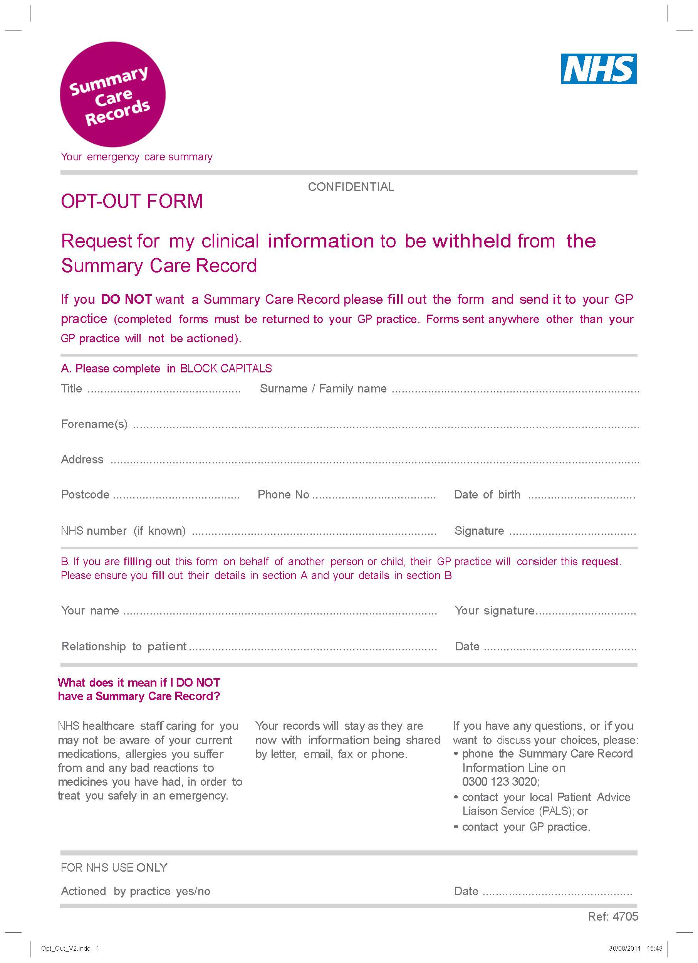

Appropriate Appointment Guide
Conditions appropriate for 999 | Conditions appropriate for A&E
- Chest Pains in patients over 40  - Difficulty Breathing/unusual for the patient  - Loss of Consciousness/difficulty rousing  - Acute Loss of Vision  - Severe bleeding/Haemorrhage  - Floppy Drowsy Babies/Children  - Stroke  - Vomiting Significant amounts of blood  - Suicide Attempts  - Early Pregnancy/Severe abdominal pain | - Head Injury  - Sprain/Fracture/Acute Injury  - First Fit or Prolonged Fit (10 mins or more)  - Epileptic Seizures  - Persistent Nose Bleed (15 minutes or more)  - New/same day injuries  - Serious Burns/Scalds  - Poisoning
Same Day Appointment with GP - Urgent/Immediate/Complex Need
- Allergic Reactions to Insect Bites/Stings  - Drug/Allergic Reactions  - Severe Pain not responding to painkillers  - Persistent Diarrhoea/Vomiting  - Vomiting blood  - Insulin dependent Diabetics | - Concern over Patients who are  - Children  - Elderly … and/or suffer from  - Chronic Conditions  - Multiple Conditions  - Terminal Illness
Same Day Appointment with Nurse – Minor Conditions (Patients over 12 months old)
- Coughs and Colds  - Sore Throats  - Flu-like symptoms  - Urine infections/cystitis  - Earache  - Chest infections  - Hay fever  - Insect bites | - Eye infections  - Sinusitis  - Diabetics with Acute Problem  - Diarrhoea or vomiting  - Emergency contraception  - Skin rashes  - Vaginal discharge
Your local Pharmacist offers advice and over the counter medications for a wide range of minor conditions. By using Pharmacy services you will be helping your Doctors to retain ‘same day’ appointments for those greatest in need.

Treating Common Conditions: http://www.nhs.uk/Livewell/Pharmacy/Pages/Commonconditions.aspx

Appointments in Advance (Pre-books)
- To discuss a new problem which may be causing concern but there is no immediate need  - Review of an ongoing problem  - Contraception and Advice  - BP or other regular checks | - Travel Vaccinations  - Health Checks  - Annual Reviews for Chronic Conditions  - Flu Vaccinations  - Review or discussion of current medications
Where ever possible please consider booking an advance appointment as this allows us to retain ‘same day’ appointments for those who are in greatest need
No Appointment Required | Practice Clinics
- Repeat Prescriptions  - Medication Queries  - Some Fit for Work Certificates (Provided upon Hospital Discharge and Continuation Certificates) | - Seasonal Flu  - Minor Ops  - Anti-Natal |  | - Baby Clinics  - Green Dreams (Social Support)
External Services
- Bloods requested by hospital |  | Drop In Clinic – Burnley General Hospital
- Health Visitor |  | The Chai Centre 01282 628549
- District Nurse, Treatment Wound Care, Ear Syringing |  | St Peters Centre - 01282 805920
- Minor Eye Conditions |  | Contact your Optician for ‘drop in’ availability
Visit www.thursbysurgery.co.uk for a copy of the ‘Burnley Directory of Services’ for patients and carers.

The list is not exhaustive but is to guide patients towards accessing an appropriate type of appointment/service

Please answer the following questions to help us better understand the mix of patients we serve.

Gender   Male   Female | Ethnicity  White   White British   White/Irish   Other White Background  Asian or Asian British   Indian   Pakistani   Bangladeshi   Chinese   Other Asian Background  Black or Black British   Caribbean   African   Indian   Other Black Background  Mixed   White and Black Caribbean   White & Black African   White & Asian   Other Mixed Background  Other   Any other Ethnicity   Prefer not to say | Carers – Are You   The Carer   The Patient or Carer   The Patient & Carer
Age   0 - 15   16 - 24   25 - 34   35 - 44   45 - 54   55 - 64   65 - 74   75 - 84   85+ |  | Orientation    Heterosexual/straight    Gay/Lesbian   Bisexual   Other   Prefer not to say
Marital

❍ Married
❍ Single
❍ Widowed
❍ Separated/Divorced
❍ Co-habiting

Health Conditions   Do you have a disability   Physical impairment   Psychological/emotional   A learning difficulty   Long term chronic condition   Condition limiting physical activity   Deafness or hearing impairment   Blindness or visual impairment   None of the above   Prefer not to say |  | Education   High School   College   Bachelor’s degree   Post-graduate   Professional
Access

Can you take time away from work to see a Doctor?
❍ Yes
❍ No
❍ N/A

Religion   None   Buddhist   Christian   Hindu   Jewish   Muslim   Sikh   Other   Prefer not to say | Employment   Yes - Full-time   Yes - Part-time   No - Unemployed   No - Home responsibilities   No - Student   No - Retired   No – Sick/Disabled | Children   Under 5   6-12 years   13-17 years old   18+   No children
Health  Is your health?   Excellent   Very Good   Good   Fair   Poor | Appointments  How often do you visit your GP?   Never   Rarely   Occasionally   Frequently | Signing  Are you a deaf person that uses sign language?   Yes   No

Patient Declarations

If accepted as a patient I confirm:
- I have completed each section of the application
- I have/have not completed the Summary Care Record ‘Opt Out Form’
- I understand that if my postcode is outside the Practice Catchment area that I may be registered as an ‘Out of Area’ Patient and understand what this entails.
- I have been informed that I will be allocated a ‘named GP’ and understand what this entails.
- That registration with the Practice remains dependent upon my willingness to be considerate of all Practice policies
- To use the services offered in appropriate manner and agree not to:
- Use routine appointments inappropriately, i.e.
- For repeat prescriptions (which should always be ordered 48 hours in advance)
- Sick notes that as a patient you have failed to order time
- Minor conditions that could be dealt with via an alternative route, (for example, self-care, over the counter medication).
- Request emergency/urgent appointments for non-urgent conditions
- Inform the Practice that something is urgent when it is not - Urgent means Urgent Clinical Need
- Demand to order repeat prescriptions over the phone.
- Fail to turn up for appointments, or, cancel/change appointments at short notice
- Adopt an aggressive or verbally abusive approach when requesting services or treatment

Any breach of this agreement will indicate a breakdown in the Practice/Patient relationship and the Practice retains the right to immediately remove you from the Practice register.
PRINT NAME
SIGNED
DATE

For Office Use Only

New Patient Applications  A clinician has reviewed your registration request and/or records to determine if registration is practically/clinically appropriate | Clinician  Review  Date | Review Outcome  (Please Tick)
Accepted |  | Register and Process SCR
Accepted as an ‘Out of Area registered patient’ without any obligation to provide home visits. |  | Read Code 912N
Not Accepted - Not clinically/practically appropriate for registration. The patient is advised to seek registration with an alternative Practice. |  | Inform Patient
GP Comments:

